

FoodBox



*(*

*Source Code)*

**A FULL STACK DEVELOPMENT**

**CAPSTONE PROJECT**

• **Version History:**

|  |  |  |
| --- | --- | --- |
| 1. | **Author Name** | Cherala Ramani |
| 2. | **Purpose** | Source Code |
| 3. | **Date** | 25 April 2022 |
| 4. | **Version** | 1.0 |
| 5. | **Contact** | *Ramanicherala999@gmail.com* |

Contents.

1. User Flow Chart Diagram 3

2. GitHub Link 4

3. Database Design 4

4. Folder Structure 6

5. Project Files 11

# User Flow Chart Diagram.

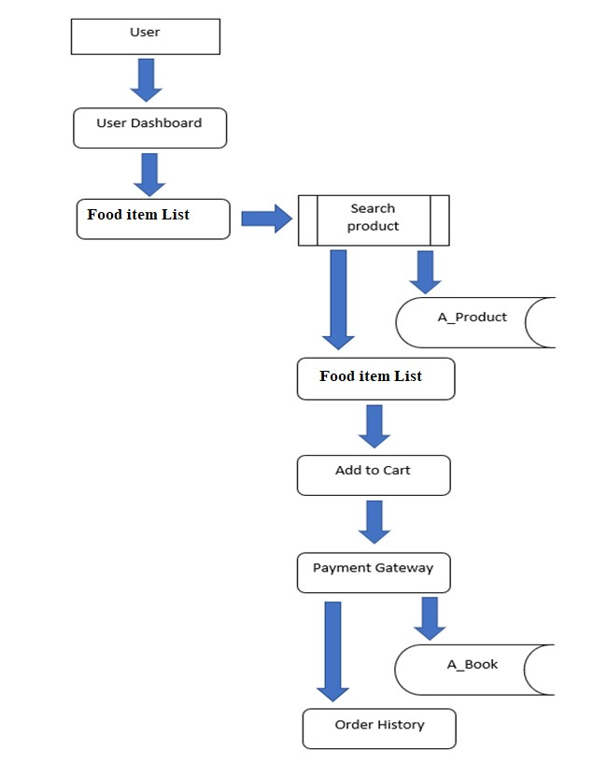

# GitHub Link.

|  |  |
| --- | --- |
| **Repository Name.** | FoodBox-Capstone-Project |
| **GitHub Link.** | <https://github.com/tuskhillare/FoodBox-Capstone-Project.git> |

# Database Design.

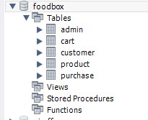

Data Result Set

:

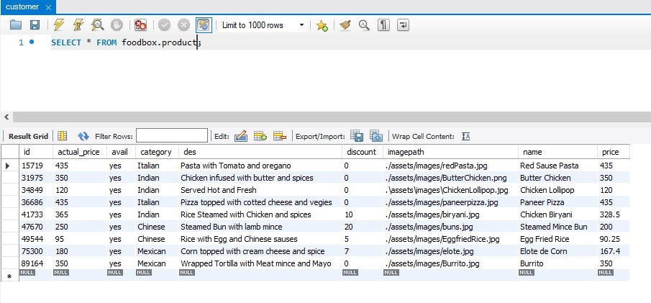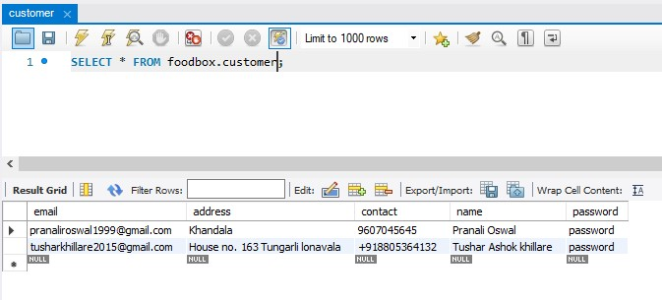

# Folder Structure.

**(Back End Development)**

Spring Project Structure

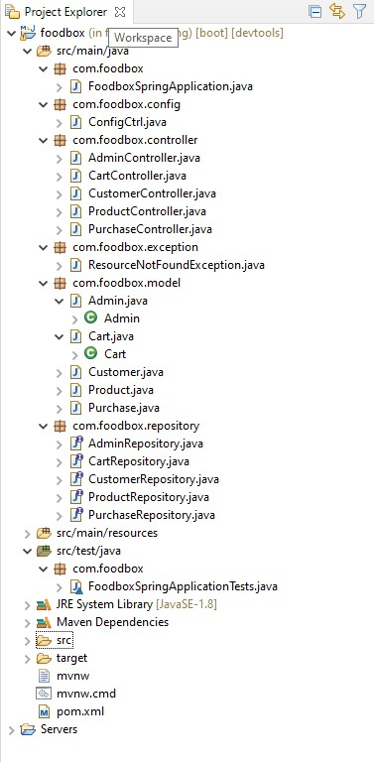

Pom.xml

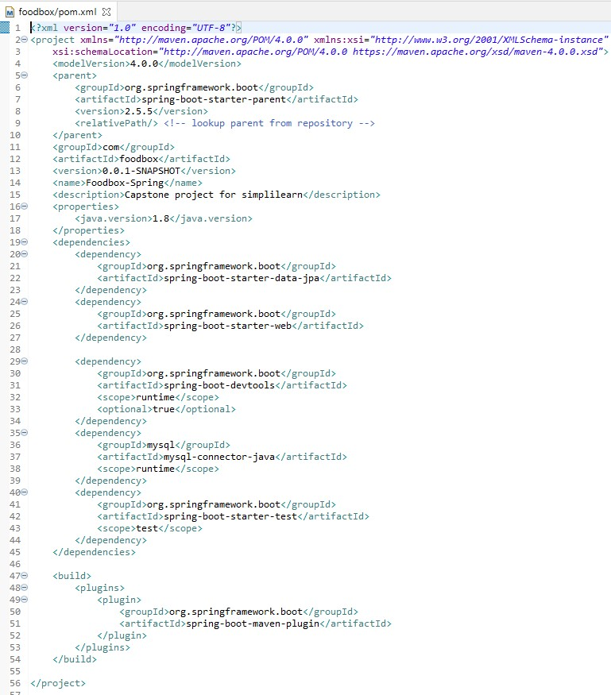

FoodSpringApplication.Java

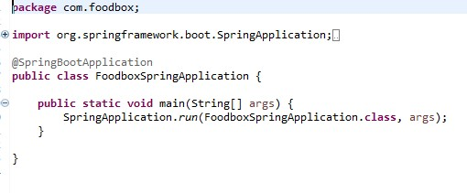

FoodboxSpringApplicationTests.Java

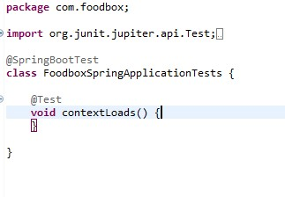

Rest of the files are present in the given GitHub link kindly refer this…

<https://github.com/tuskhillare/FoodBox-Capstone-Project.git>

Spring Output:

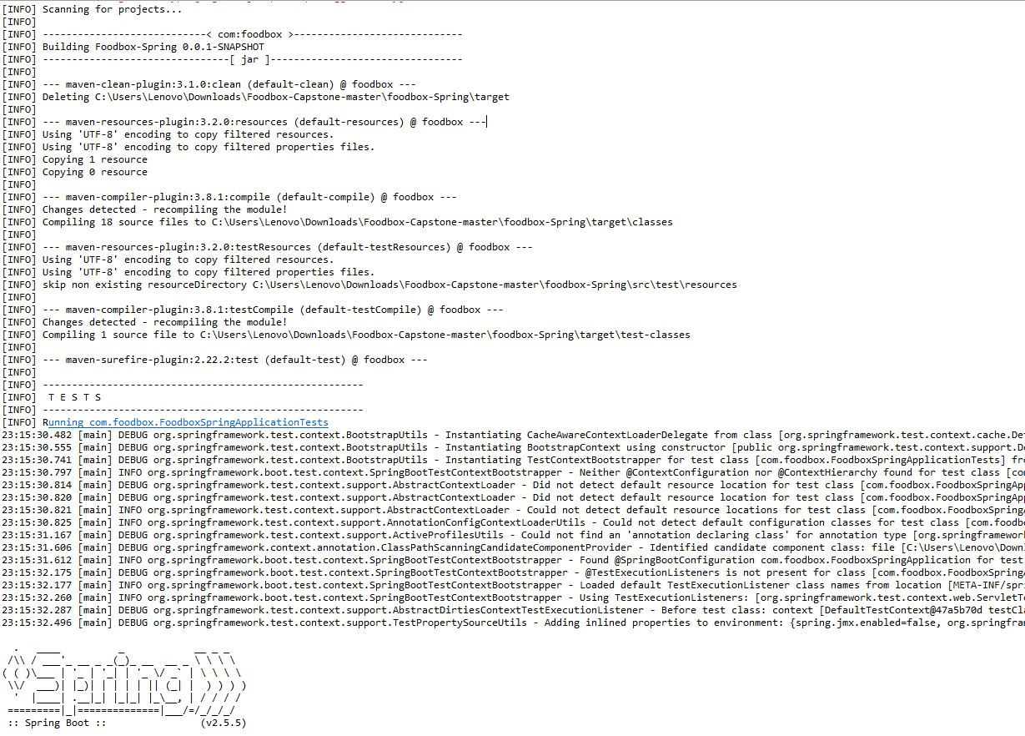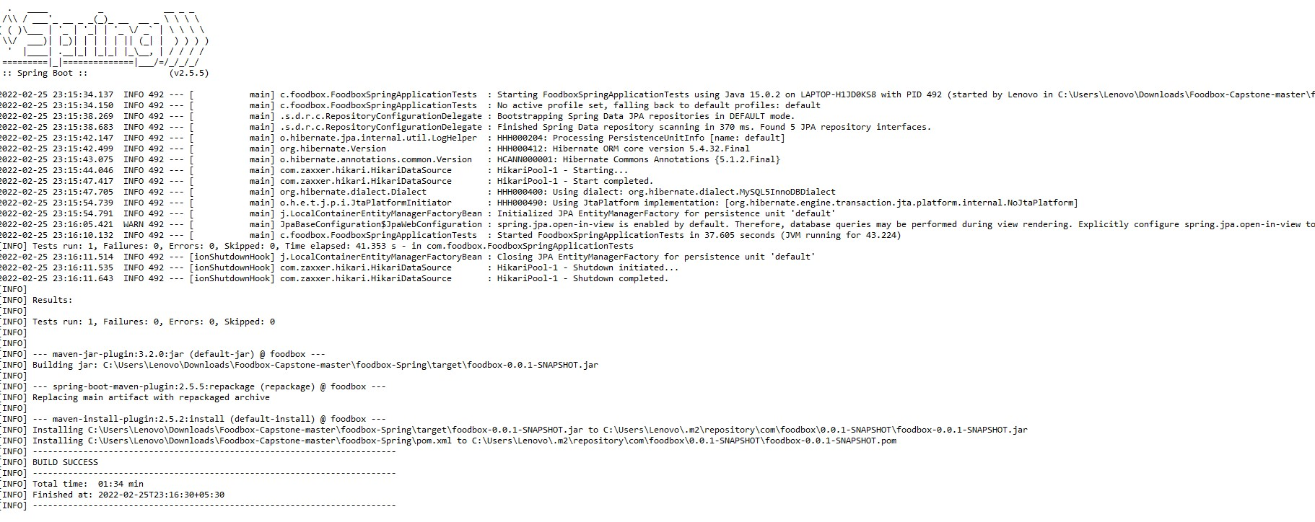

**(Front End Development)**

Angular Project Structure:

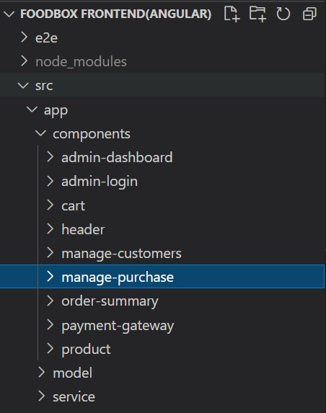

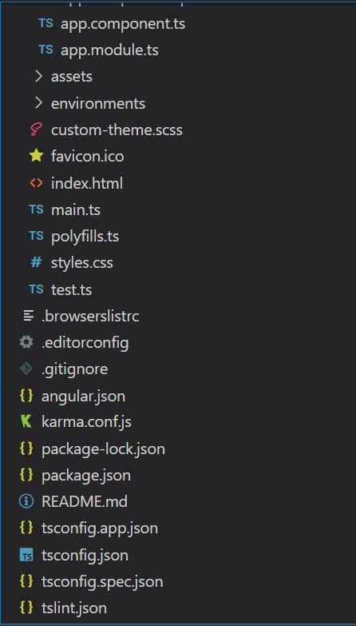

# Project Files.

Index.html

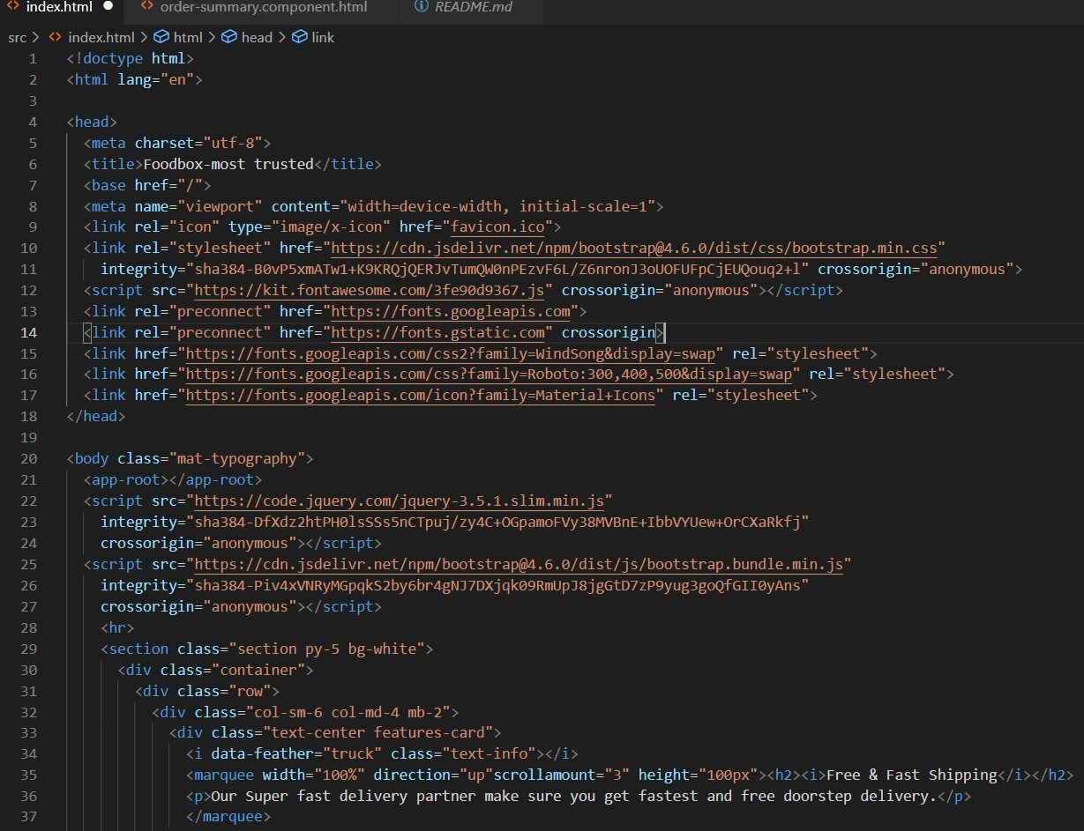

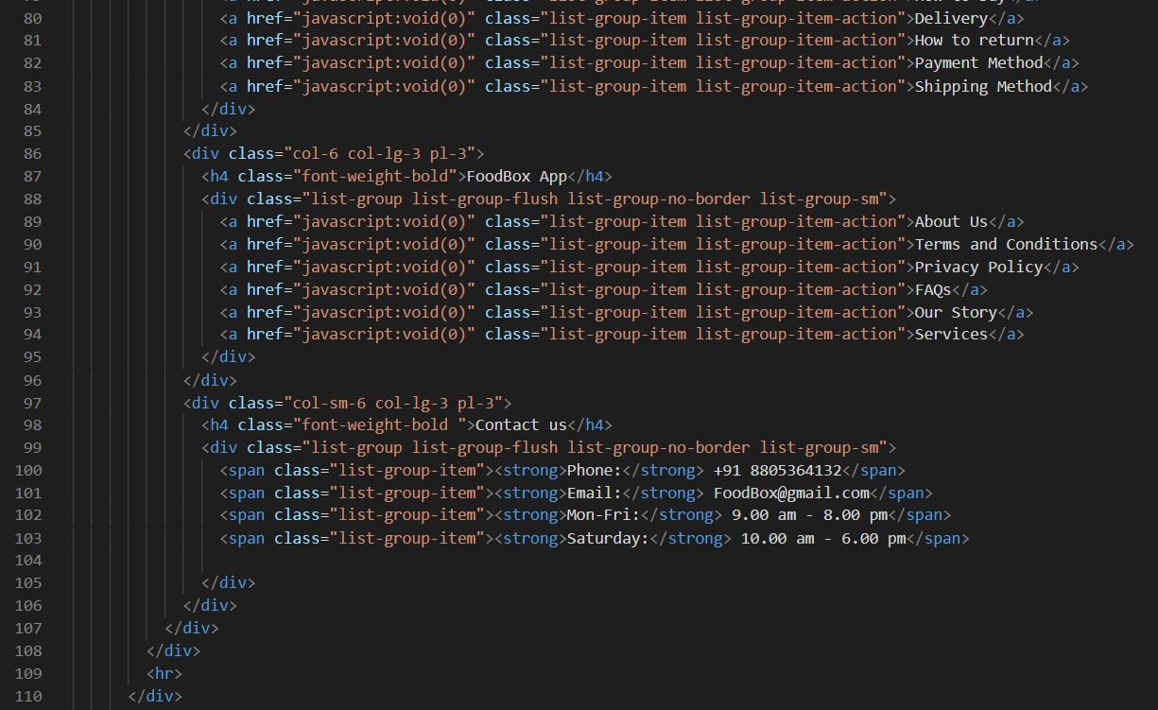

test.ts:

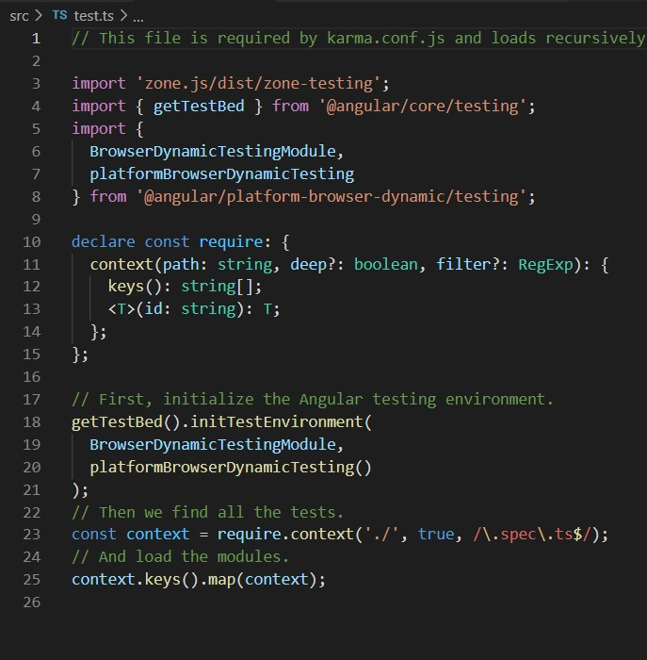

Rest of the files are present in the given GitHub link kindly refer this… <https://github.com/tuskhillare/FoodBox-Capstone-Project.git>

Package.json:

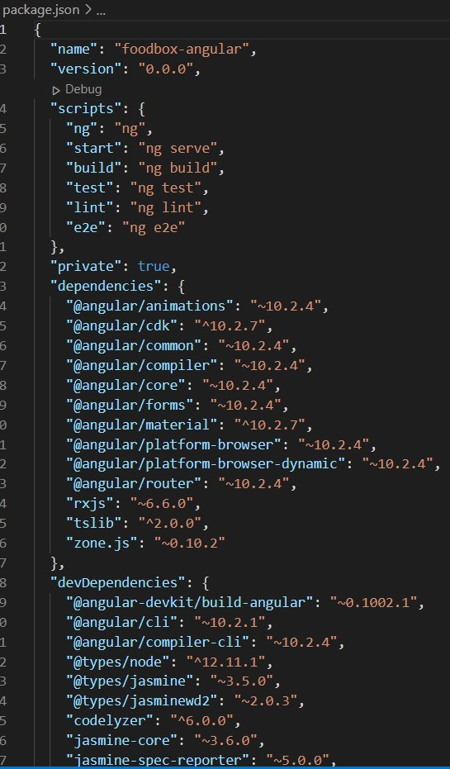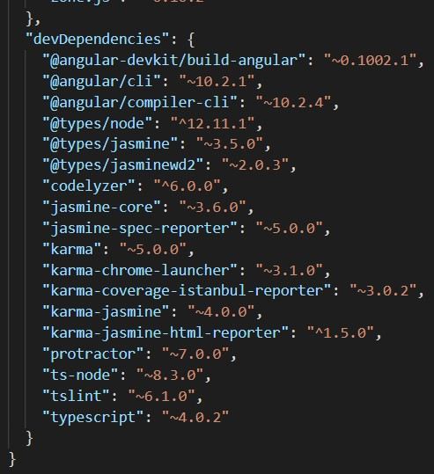

Angular Outputs:

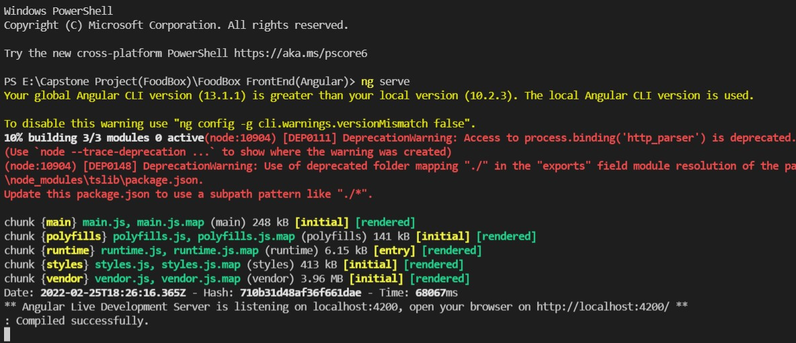

Thank You……………